Great Course Companions

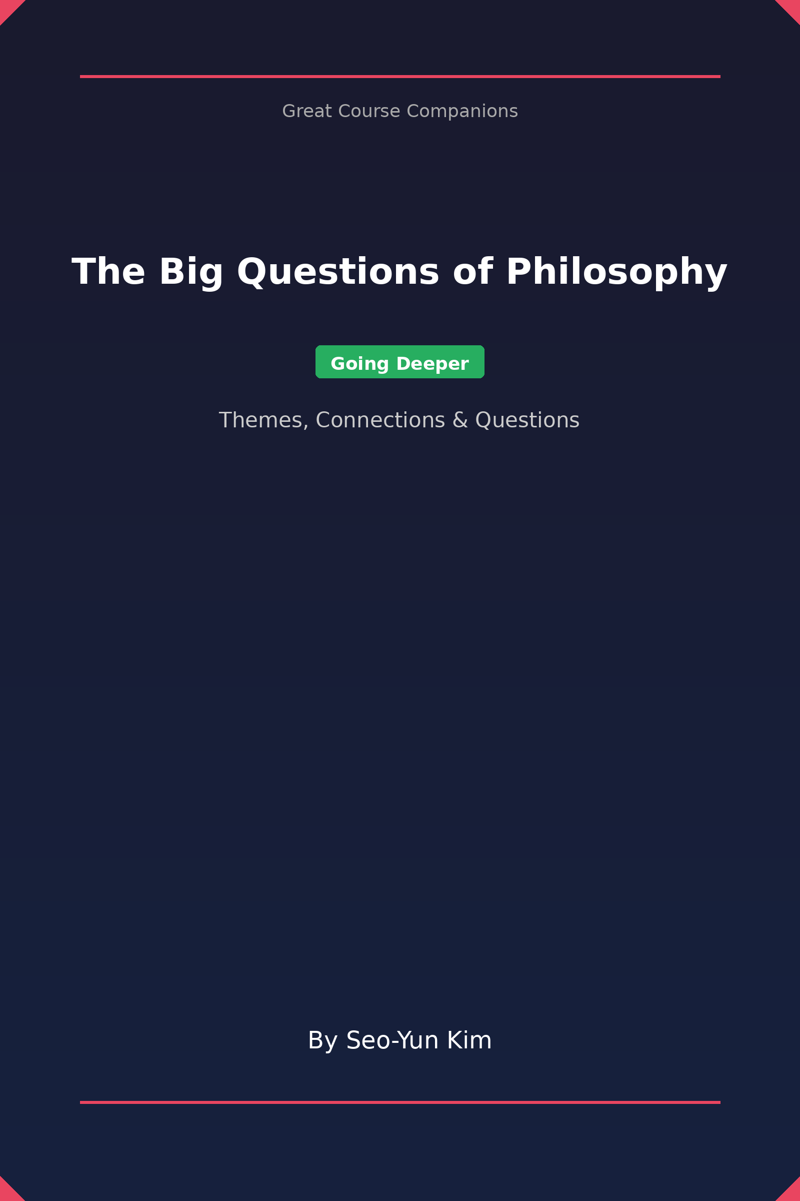

The Big Questions of Philosophy
  - Themes, Connections & Questions
— Going Deeper —

By Seo-Yun Kim

Copyright © 2026 Seo-Yun Kim
All rights reserved.
Published by Independent Publishing
First Edition: January 2026
ISBN: [Pending]

IMPORTANT NOTICE
This companion guide is an independent educational resource created to enhance your learning experience. It is not affiliated with, endorsed by, or connected to The Great Courses, The Teaching Company, or any course instructor.
All original content, analysis, discussion questions, and synthesis in this guide are the intellectual property of the author. This guide is intended as a transformative educational work that provides original commentary, analysis, and study materials.
No part of this publication may be reproduced, distributed, or transmitted in any form without prior written permission of the publisher, except for brief quotations in reviews and educational contexts.

Table of Contents
[To generate: In Word, go to References → Table of Contents → Automatic Table 1]

Course Overview
The course 'The Big Questions of Philosophy' delved into fundamental issues regarding human existence, morality, and the structure of society. It provided a platform for students to engage with the thoughts of pivotal philosophers such as John Stuart Mill, John Rawls, and others, examining their perspectives on liberty, justice, and the search for meaning. By critiquing these theories, the course illuminated how philosophical ideas shape our understanding of the world and influence our daily lives. It also encouraged students to think critically about the roles of government, society, and individual responsibility in fostering a just and meaningful existence.
Throughout the lectures, learners explored the delicate balance between personal freedoms and societal obligations, grappling with the question of how much liberty should be sacrificed for the sake of the common good. This exploration was not merely academic; it sought to connect these age-old questions to contemporary challenges, such as socioeconomic inequality, individual rights, and the quest for a meaningful life. The philosophical inquiries posed in this course serve as a foundation for students' ongoing engagement with these complex issues beyond the classroom.
The interplay of philosophical thought with real-world issues underlined the relevance of this course. Students were encouraged to recognize that these philosophical questions are not just historical artifacts, but rather living dialogues that continue to evolve in response to changing societal contexts. As such, the course equipped students with the tools to navigate the ethical challenges they will inevitably face in their lives and careers, fostering a deeper understanding of their own values and beliefs.

Major Themes

Liberty vs. Authority
The tension between individual freedom and governmental authority emerged as a central theme throughout the course. Beginning with Mill's arguments on the importance of personal liberty, students explored how different political philosophers grappled with this balance. Mill's utilitarianism posed questions about the extent to which liberty should be curtailed for the greater good, while Locke's social contract theory emphasized the protection of individual rights. The discussions culminated in the recognition that while some degree of authority is necessary for social order, it is crucial to protect individual freedoms against overreach.
This theme was further developed through the exploration of Rawls' theory of justice, which advocates for a fair distribution of resources while maintaining individual liberties. The philosophical debates surrounding this theme challenge students to consider the implications of their own beliefs about governance and personal rights. By examining historical and contemporary examples, the course illustrated the complexities involved in defining and protecting liberty within various societal frameworks.
Key Lectures: Lectures 1, 2
Connections: This theme connects to fields such as political science, law, and ethics, raising questions about the role of government in regulating behavior and protecting individual rights. It also resonates with current debates on surveillance, freedom of speech, and social justice.

Concepts of Justice
The exploration of justice, particularly through the lens of Rawls' theory of justice as fairness, highlighted the philosophical underpinnings of equitable distribution and societal obligation. Rawls' principles advocate for a system where societal structures benefit the least advantaged, challenging traditional notions of meritocracy and individual success. This theme encouraged students to critically assess contemporary inequalities and the role of government intervention in creating a just society.
Moreover, discussions on justice were enriched by examining various critiques and alternative frameworks, such as those proposed by libertarians and communitarians. By engaging with these differing perspectives, students gained insight into the multifaceted nature of justice and its implications for public policy and ethical decision-making. The complex interplay of justice with liberty and individual rights underscored the challenges of achieving a truly fair society.
Key Lectures: Lectures 2
Connections: This theme links to social justice movements, legal theory, and economic policy, providing a framework for understanding debates around wealth distribution, affirmative action, and systemic inequality.

Existential Meaning
The inquiry into the meaning of life, as introduced in Lecture 3, directed attention to existentialism and human purpose. Through the lens of literary and philosophical narratives, students examined how individuals construct meaning in a seemingly indifferent universe. The course employed examples from literature, such as Douglas Adams' 'The Hitchhiker's Guide to the Galaxy,' to illustrate the absurdity of existence and the human quest for significance amid chaos.
This theme prompted students to reflect on their personal beliefs and experiences, fostering a deeper understanding of how meaning is derived from relationships, achievements, and the pursuit of knowledge. It also engaged with the broader existentialist tradition, inviting comparisons with thinkers like Sartre and Camus. The exploration of existential meaning underscored the importance of agency and choice in shaping one's life narrative.
Key Lectures: Lecture 3
Connections: Existential meaning intersects with psychology, literature, and theology, prompting discussions about mental health, the human condition, and the search for purpose in contemporary society.

Ethics and Responsibility
The course prompted critical examinations of ethical frameworks and the responsibilities that accompany individual freedoms. Through discussions of utilitarianism, deontology, and virtue ethics, students explored how different moral theories guide ethical decision-making. The application of these theories to real-world dilemmas illustrated the complexities of moral responsibility and the potential conflicts between personal desires and societal norms.
Students were encouraged to consider their own ethical stances and the implications of their choices on others. This theme emphasized that ethical considerations are not merely theoretical; they play a crucial role in shaping personal and collective actions. By engaging with contemporary ethical issues, such as environmental ethics and bioethics, students recognized the relevance of philosophical inquiry in navigating moral challenges in their lives.
Key Lectures: Lectures 1, 2, 3
Connections: This theme connects to areas such as law, business ethics, and environmental studies, highlighting the importance of ethical considerations in professional practices and societal development.

The Nature of Knowledge
Discussions surrounding knowledge and belief were woven throughout the course, particularly in relation to the limits of human understanding and the pursuit of truth. Engaging with epistemological questions regarding what constitutes knowledge, how it is acquired, and the impact of belief systems prompted students to reflect on their own cognitive processes and biases. This theme was particularly relevant in the context of contemporary challenges such as misinformation and the role of scientific inquiry.
By examining the philosophical underpinnings of knowledge, students learned the importance of critical thinking and skepticism in evaluating claims. The exploration of different epistemological perspectives, from empiricism to constructivism, deepened their understanding of how knowledge is constructed and disseminated. This theme highlighted the dynamic interplay between knowledge, belief, and societal progress.
Key Lectures: Relevant throughout the course
Connections: This theme connects to cognitive science, education, and media studies, emphasizing the significance of knowledge production and dissemination in shaping public discourse and policy.

Deeper Questions

What is the relationship between freedom and responsibility in a just society?
The interplay between freedom and responsibility raises profound questions about individual agency and social accountability. In a just society, individuals must balance their rights to liberty with their obligations toward others. This relationship is further complicated by the varying interpretations of what constitutes 'responsibility.' For instance, some may argue that true freedom necessitates personal responsibility in decision-making, while others may contend that societal structures should bear the burden of ensuring equitable opportunities for all.
Exploring this question invites students to consider the ethical implications of their choices and the extent to which they are accountable for the welfare of their community. It also challenges them to reflect on how societal norms and laws shape perceptions of responsibility. Ultimately, the relationship between freedom and responsibility is crucial for fostering a just society where individual liberties are preserved without compromising the collective good.
Further Reading: Consider reading 'The Ethics of Liberty' by Murray Rothbard or 'Justice: What's the Right Thing to Do?' by Michael Sandel for deeper exploration of freedom and responsibility.

How do we define a meaningful life in the face of existential uncertainty?
Defining a meaningful life amid existential uncertainty is a question that resonates deeply in philosophical discourse. In an era characterized by rapid change and unpredictability, individuals grapple with the challenge of finding purpose in their lives. Philosophers like Viktor Frankl argue that meaning can be found through suffering and personal growth, suggesting that individuals possess the agency to create their own significance.
This question invites reflection on what values and experiences contribute to a fulfilling life. It poses challenges to societal definitions of success and happiness, urging individuals to reconsider their priorities and aspirations. Engaging with this question can lead to transformative insights about the nature of existence and the human condition, ultimately guiding individuals towards a more intentional and purposeful life.
Further Reading: Explore 'Man's Search for Meaning' by Viktor Frankl and 'Existentialism is a Humanism' by Jean-Paul Sartre for deeper engagement with existential questions.

What role does philosophy play in addressing contemporary social issues?
Philosophy plays a vital role in addressing contemporary social issues by providing frameworks for critical analysis and ethical reasoning. The philosophical tools developed throughout the course equip students to engage thoughtfully with pressing challenges such as climate change, inequality, and technological advancement. By applying ethical theories and principles, individuals can evaluate the implications of policies and societal norms, fostering informed dialogue and action.
Moreover, philosophy encourages individuals to consider diverse perspectives, promoting empathy and understanding in addressing social divides. As society grapples with complex issues, the philosophical inquiry fostered in this course serves as a catalyst for deeper reflection, ultimately guiding individuals toward more just and equitable solutions.
Further Reading: For further exploration, read 'A Theory of Justice' by John Rawls and 'The Moral Landscape' by Sam Harris, which address the intersection of philosophy and social issues.

Intellectual Connections
Related Fields: Political Science, Ethics, Psychology, Sociology
Key Thinkers: John Stuart Mill, John Rawls, Immanuel Kant, Simone de Beauvoir

The philosophical inquiries explored in this course resonate powerfully with contemporary issues such as social justice, political polarization, and existential anxiety. As individuals navigate an increasingly complex world, the principles of liberty, justice, and ethical responsibility become crucial in shaping public discourse and policy. The teachings of influential philosophers provide essential insights for understanding and addressing these challenges, encouraging individuals to cultivate critical thinking and ethical awareness in their personal and professional lives. Furthermore, as societal values evolve, philosophical inquiry remains a vital tool for re-evaluating norms, fostering inclusivity, and promoting meaningful dialogue in an interconnected global community.

Synthesis
The course 'The Big Questions of Philosophy' has provided a comprehensive exploration of fundamental philosophical themes that resonate throughout human experience. By examining liberty, justice, meaning, ethics, and knowledge, students have gained valuable insights into the complexities of modern life. The interplay of these themes underscores the importance of philosophical inquiry in navigating personal and societal challenges, fostering a deeper understanding of individual rights and collective responsibilities.
As students reflect on their learnings, they are encouraged to engage with the broader implications of these philosophical concepts, recognizing their relevance in shaping contemporary discourse around social justice, governance, and personal fulfillment. The questions raised throughout the course invite ongoing reflection and dialogue, inspiring students to apply their philosophical insights to real-world contexts.
Ultimately, the course has equipped students with the intellectual tools to critically examine their beliefs and values, fostering a sense of agency in addressing the challenges they will encounter in an ever-evolving world. The philosophical journey undertaken in this course serves as a foundation for lifelong learning, encouraging students to remain curious and engaged with the profound questions that define the human experience.

About the Author
Seo-Yun Kim is an independent educational writer and course companion author specializing in making complex academic content accessible to lifelong learners.
With a passion for philosophy, science, and the humanities, Seo-Yun creates study guides that help students and curious minds engage more deeply with great courses and lectures from top professors.
The Great Course Companions series provides thoughtful analysis, discussion questions, and synthesis to transform passive viewing into active learning.
Connect with the author:
• Email: [contact email]
• Website: [website]
Other titles in the Great Course Companions series:
[More titles coming soon]

